DATA STUDIO ASSIGNMENT

1] Which gender is getting the Highest salary offered based on Specialization (e.g., Mkt&Fin, Mkt&HR)?

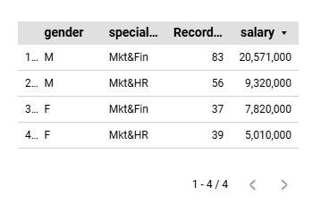

2]How does E-test performance (technical test) correlate with salary?

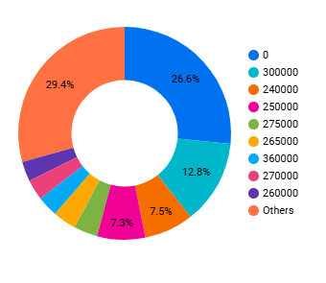

3]Which gender gets more salary?

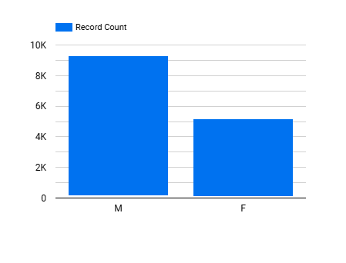

4]"Which MBA specialization has the highest gender diversity in terms of headcount?"

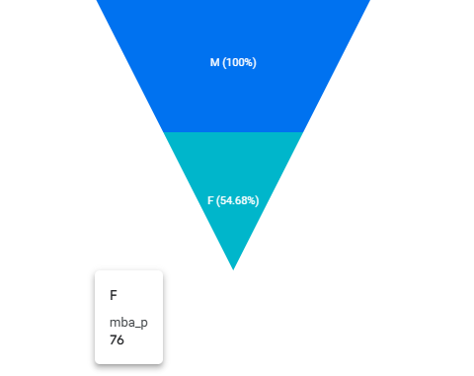

5]Can you explain who are all placed and non placed in the dataset based on deg_p & etest_p?

